Rovesti Gabriel

Wireless networks for mobile applications simple (for real)

Summary

Presentation 2

Mobile communications and Wireless Systems 5

# Presentation

Palazzi registers all the lessons via Zoom

One can also find material of reference (will not be updated overtime though): <https://www.math.unipd.it/~cpalazzi/WNMA.html>

Everything else is on Moodle. The program is as follows:

* Introduction, wireless systems, protocols architecture, issues and measures
* Physical Layer (fundamentals and mobility effects)
* Data Link Layer (fundamentals on duplexing, TDMA, FDMA, CDMA)
* Network Layer (addressing/routing with device mobility)
* Transport Layer (Reliable communication and mobility impact on TCP)
* Application Layer (Geolocalized services, DTN, smart applications, distributed sensing, crowd computing, intelligent transportation system,…)
* Wireless Network Architectures: management and challenges
* WLAN, Infrastructure and Hot-Spot Networks
* Wireless Mesh Networks (WMN)
* Sensor Networks (Sensor Networks)
* Mobile Ad Hoc Networks (MANETs)
* Vehicular Ad-Hoc Networks (VANETs)
* Flying (Drone) Ad-Hoc Networks (FANETs)
* Satellite systems, challenged networks
* Consumer market technology; main standards; advanced issues:
* IEEE 802.11b/g/a/e/n/s/p
* IEEE 802.15.1 (Bluetooth)
* IEEE 802.15.4 (ZigBee)
* RFID
* Services:
* Location-based services
* Client/Server and alternative service paradigms
* Wireless Internet
* Pervasive wireless communication systems
* Other fields where Wireless Networks apply: existing and visionary services

The project can be on whatever scenario for the exam, will be any kind of project.

* Practical implementation or study of course-related scenarios
* Performance evaluation of protocols in wireless scenarios
* Development of applications for mobile environments (e.g., videogames or other applications for smartphones)

The specs for the project are as follows:

4 pages are enough, but students find them too short for the report for the project. We will discuss with the professor, and we both have to agree on that (via a meeting or I don’t know). It may be much related to Networking but also something completely different.

One can create a big project to satisfy both Mobile Programming and Multimedia and this course; this is also a chance.

The project has this kind of evaluation criteria:

This is class on:

* Design, analysis, and implementation of protocols and algorithms in (mobile) wireless network systems and their implication in the design of popular/innovative mobile applications

This does not cover:

* Modulation schemes, transmitter/Receiver design, signal processing and antenna design, source coding / channel coding, privacy / Security

The project can be done in pairs (strongly suggested, 2/3 people per team)

The exam is oral, not written, which is an oral examination. Then the project can be delayed and decided to a term even after the examination. The teacher is flexible on this.

We are supposed to read papers to explore and further dive on a particular topic, to absorb concepts, for ourselves and to rationalize different ideas and different solutions. Via the intranet of UniPD inside the Department, we can freely access our specific papers.

General criteria on how to write the papers:

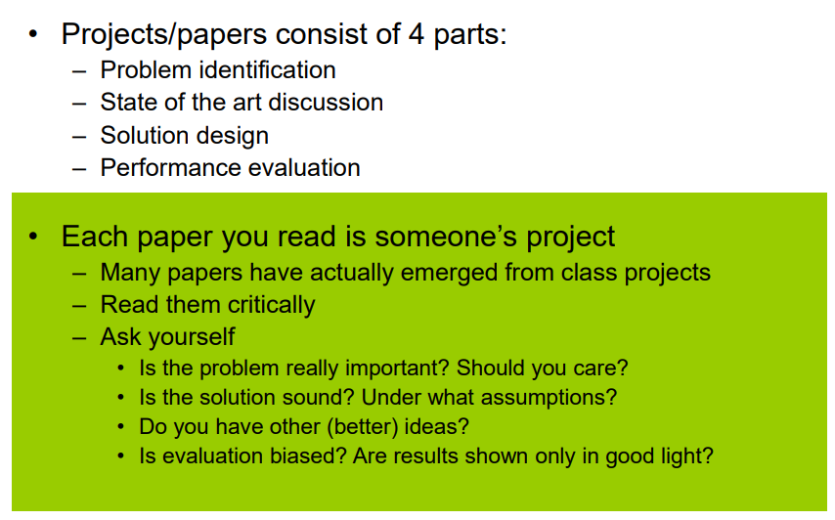

It’s important to discuss ideas and thoughts with the professor, mainly on an area and direction and find new solutions for more problems.  
Also:

# Mobile communications and Wireless Systems

In the history of communication, the main thing is transmitting data, no matter the channel. Several ways of communication have born, but others have made their way to conquer the world: the mobile ones, with an exponential growth in connections and devices since 1988.

Now device penetration goes between 80% to over 120/140% all over the continents, with the most connections coming from Asia, China, Africa and India, with mobile subscriptions approximately at almost 9 billion. Connection has overtime become ubiquitous, reaching billions of users and devices worldwide.

The following is an example of how networks are created differently, trying to penetrate the whole environment for the sake of communication universally. We want to run data making a good compromise between performance and effectiveness, depending on the scenarios listed above. We can’t plan them definitely: there will always be delays, energy struggles, position of nodes and other factors to consider in this environment.

Above, just for mobile and IOT, you can see the fragmentation, in which each one requires different specifications on how data will be transmitted:

The largest part of mobile data consumption is taken up by video data, may it be streaming, VoD (Video on Demand) and other video formats, possibly even HD/UHD, AR/VR. Following we may find social networking, software downloads and updates, etc. As years have passed, users have changed overtime their behavior, tending to consume media everywhere and devices with larger screens require better media and heavier networking use (so, reduce in usage of older G technologies such as 3G and increase in 4G and 5G).

Internet usage and the widespread adoption of laptops have reached unprecedented levels. This surge in demand for connectivity has driven advancements in wireless technology to support high-speed and reliable data transmission. Wi-Fi standards are continually improving, and the transition from 4G to 5G and now to 6G is reshaping wireless communication capabilities.

Wireless technology is now integrated into interdisciplinary applications, opening multiple realities scenarios, ultra responsive at our touch (Tactile Internet) and intraconnected in realtime with wide range of data demands (Web Squared).

To summarize, we can see below the different types of networks, whereas the need of expanding connectivity and enabling different applications according to a seemingly ever-evolving context:

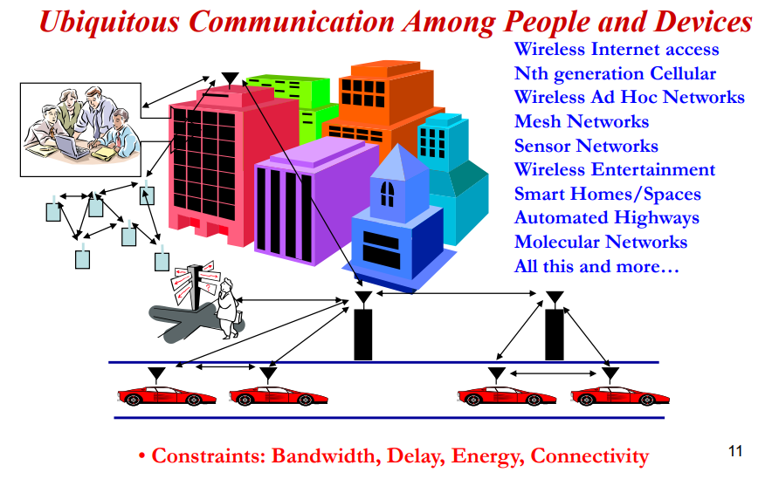

* Wireless channels have limited bandwidth compared to wired counterparts. This limitation poses a challenge in achieving high data rates, especially as the demand for wireless data continues to grow. One solution is trying to use protocols and techniques to maximize channel capacity.
* Wireless networks operate in dynamic environments where user locations, traffic patterns, and network conditions change continuously. This variability can lead to unpredictable performance. The solutions are using algorithms and protocols to adjust to changing conditions.
* There are applications with varying requirements, having different Quality of Service mechanisms to help prioritize traffic and having applications energy-efficient and protocols that use low-power algorithms to optimize consumption

Energy and delay constraints *change design principles* across all layers of the protocol stack. Below the general multimedia requirements between different types of media (where BER stands for Bit Error Rate):

A few considerations:

* For data we don’t care about content transmission of every single packet, but for the total time of having the whole thing downloaded, without losing packets. Usually data is burst continuously, minimizing the total download time
* On the other side, games, voice (VoIP) are requiring applications where data is streamed uninterruptedly to maintain a seamless user experience
* In the case of video, whether it's real-time streaming or playback of prerecorded content, video transmission involves the transfer of large volumes of data. To deliver a smooth viewing experience to end-users, it's essential to use larger packets and efficiently handle the bursty nature of video data

In computer networks design, we have layers, as something called the *crosslayer design*, based on constraints of transmission between delay, rate and energy, causing the loss of packets. It’s advisable to focus “on your layer” when creating a network application, without having something universal but functional (without sacrificing exploitation of more possibilities).

What we essentially mean is creating something carefully, having each layer naturally interact with others, without “crossing borders” unsafely, but *propagated*.

Let’s introduce the Current Wireless Systems, crafting something like:

* Cellular Systems, where geographic regions are divided into cells, crafting areas to reuse spatially frequencies/timeslots/codes between cells and coordinating handoffs via control functions. We also must consider cell size (shrinking it means increasing capacity but also networking burden) and conflicting technology between cells, to keep the service alive.
  + Data is bursty, having 3G widening the data pipe (with both voice and data), while 4G and 5G more focused on data (higher bandwidth and reliability, lower latency)

* Wireless Local Area Networks (LANs), which connect local computers (between a 100m. range), breaking data into packets and sharing channel access randomly. This backbone provides best-effort service, which means they prioritize delivering data with no guarantees of quality or timeliness.
  + This can lead to overhead due to the need to retransmit smaller packets but can be more forgiving in terms of data loss.
  + There is a trade-off in bandwidth utilization. The shared nature of the channel means that it's not always fully utilized because of the various tasks competing for time on the channel, which include voice communication, data consumption, and packet transmission

Just to give a quick overview of WLAN Standards:

* **802.11b (Old Generation) – free frequency, more crowded**
  + Frequency: 2.4GHz ISM band
  + Modulation: Frequency hopped spread spectrum
  + Speed: 1 - 11 Mbps
  + Range: Approximately 100 meters (nominal)
* **802.11g (Legacy Standard) – popular and with higher bandwidth usage**
  + Frequencies: 2.4 GHz and 5 GHz bands
  + Modulation: OFDM (Orthogonal Frequency-Division Multiplexing), transmitting data and dividing it into multiple subcarriers, resistant to interference and able to multipath
  + Speed: Up to 54 Mbps (nominal)
* **802.11n (Current Generation)**
  + Frequencies: 2.4 GHz and 5 GHz bands
  + Modulation: OFDM with time division
  + Technology: MIMO (Multiple-Input and Multiple-Output), uses multiple antennas at both the transmitter and receiver, enabling simultaneous transmission of multiple data streams
  + Speed: Up to 300 Mbps (nominal)
* **802.11ac (Current/Emerging Generation):**
  + Frequencies: 2.4 GHz and 5 GHz bands
  + Modulation: OFDM with time division
  + Advanced MIMO: More MIMO (Multiple-Input and Multiple-Output) channels
  + Speed: Up to 500 Mbps (nominal) for a single connection
* Wireless Mesh Network
* Satellite Systems
* Bluetooth
* RFID
* D2D